11762 – 106 St.
Edmonton, AB T53 4Y7

April 13, 2020
……………………………
Instructor, ENGL1102
Northern Alberta Institute of Technology 11762 – 106 St.
Edmonton, AB T53 4Y7

Dear sir/madam:
“A Technical Description: Physical Features and Operation of the sump pump as well as its operating cycle. You authorized the report during week 7 of the ENGL1102 course.

The report is organized into three main sections: an introduction that provides a definition summarized description of the valve, the main body section that describes each major part in detail, and a conclusion that briefly describes the functional overview and operating cycle of the valve.
I would be more than happy to respond to any questions that you may have regarding the report. You can contact me by email at -----------------

Sincerely,

---------------
Mechanical Engineering
ENGL1102
Northern Alberta Institute of Technology
Edmonton Alberta

As a submission to
--------------------------
Prepared by ----------------

ENGL1102 Technical Description
Project Mechanical Engineering
Technology
November 20, 2020

Contents
1.0 INTRODUCTION 4
1.1 Definition and Purpose 4
1.2 Summarized Description 4
1.3 Background 4
1.4 List of Major Parts 5
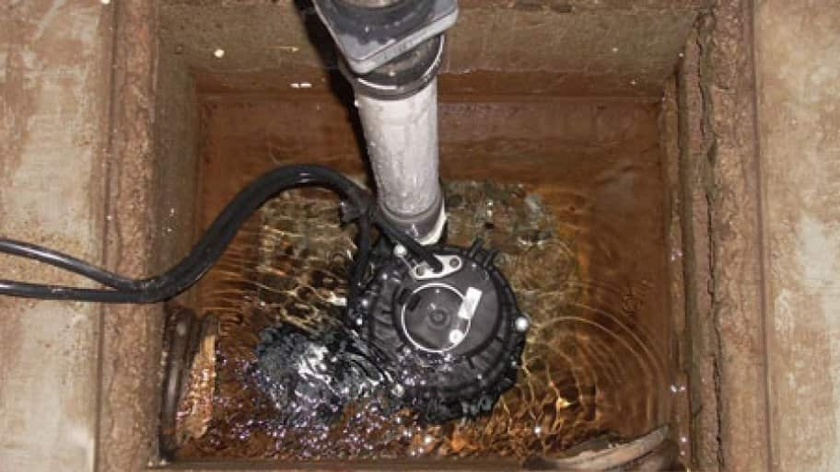 8
2.0 DESCRIPTION AND FUNCTIONS OF MAJOR PARTS 8
2.1 Motor 8
2.2impeller 8
2.3 discharge 9
2.4 discharge pipe 10
2.5 switches 11
2.6 check valve 12
3.0 CONCLUSION 12
3.1 Functional Overview 12
3.2 Operating cycle 13
4.0 REFFERENCES 14

1.0 INTRODUCTION

1.1 Definition and Purpose
It is a pump used to drain water that is stagnant in water-collecting basins or unwanted basements at home. The water may enter through the drainage systems of a building funnelling into the water collecting basin. The water flood from rains or just natural groundwater. Sump pumps are sometimes used in sewage treatments or disposal of water into the drainage systems.

1.2 Summarized Description
There are two types of sump pumps: pedestal pump. This pump is serviced more easily when the motor is above the sump, and it is more visible. The impeller of the pump is driven by a long extension shaft, and the impeller is at the bottom of the pump,
Submersible pump. Found inside the pump and it is usually sealed to prevent electrical short circuit. The pedestal sump pump has a long life of up to 25-30 years if well installed and kept off debris. They are cheaper and easier to remove. The submersible pump has a life of up to 15 years. They are expensive but do not clog upon taking up debris ("Pedestal Sump Pumps". Retrieved January 14, 2014)
Various aspects should be considered in the selection of a pump. The criteria are as follow:
- Automatic vs manual- a pump may be controlled automatically by a level switch. Automatic pumps are more efficient as they don’t need a person to trigger the discharge process, although it is said to be more expensive than the manual.
- Power- the power of a sump pump reflects directly on its performance and cost. The higher the power the costly it is and more efficient the power varies from ¼ horsepower to multiple horsepowers.
- Head pressure- determines the capability of the pump to discharge water. Mostly measured as the height capability to pump.
- Power cord length- Running a more powerful electrical motor a long distance from the main service panel will require heavier gauge wiring to assure sufficient voltage at the motor for proper pump performance (Cameron, 2008).
- Phase and voltage- AC powered sump pumps have different voltage induction motors. They vary from 110-120. 220-240, or 460.
- Water level sensing switch.
- Backup system and alarm
Sump pumps like any other operating machines requires maintenance. It is essential to at least service the sump pump system once a year to ensure efficiency in operation. Failure to service may lead to flooding of the buildings which might cause destruction of the structures (sump pumps basement repair 2013). The sump pump should also be cleaned up during servicing to remove all clogging debris that might affects its normal operation and also to replace worn out parts that reduce efficiency. Clogging would reduce the power of the sump pump making it to overheat during the operation and this might cause inter malfunctioning and reduce efficiency of the pump. It is also advisable to check the floating switches during service as they are prone to rusting agents since are usually half submerged in the water basin

1.3 Background
Today’s buildings and construction are clear from flooding water, invention of pump dates back to 2000BC when Egyptians invented the first pump. Earlier people used to use buckets to drain water from buildings. This first pump was invented from the use of bucket where the bucket was placed in a rod with a weight on the other end. By 200BC the pump was more advanced by Ctesibius who invented an air pump which had a tank of water stuck between valves and pipes on top. It was then dunked into a pool of water and then pulled out. Another person by the name Archimedes invented a pump which was known the greatest of all time. Today this invention is still in used up to date and it is known by the name of the Archimedean screw pump. It pumps both liquid and granulated solids. This pump is commonly used in industries to dispose their waste as their waste products are usually granulated solids and liquids. In developing world it is also used as an irrigation pump since it has cheap maintenance needs and durable.
An Italian by the name Francesco di Giorgio invented the first centrifugal pump in 1475. The pump have been modified in today’s world to a simple machine which is still in use for domestic purposes and industrial use.
Sump pump was invented back in the year 1946 by the U.S electrician, Karl Niedermeyer, The main reason for invention was to reduce the water accumulation on buildings foundation. This is possible by digging a sump pit which is dug at the lowest part of the building to give way for the excessive accumulating water. A sump pump is then installed to discharge the water once it is turned on through a discharge pipe to a drainage pipe. The sump pump is automated in such a way that it turns itself on once the sump pit tank is full.

1.4 List of Major Parts
The sump pump comprises of the following parts
- Motor
- Impeller
- Discharge
- Discharge pipe
- Switches
- Check valve

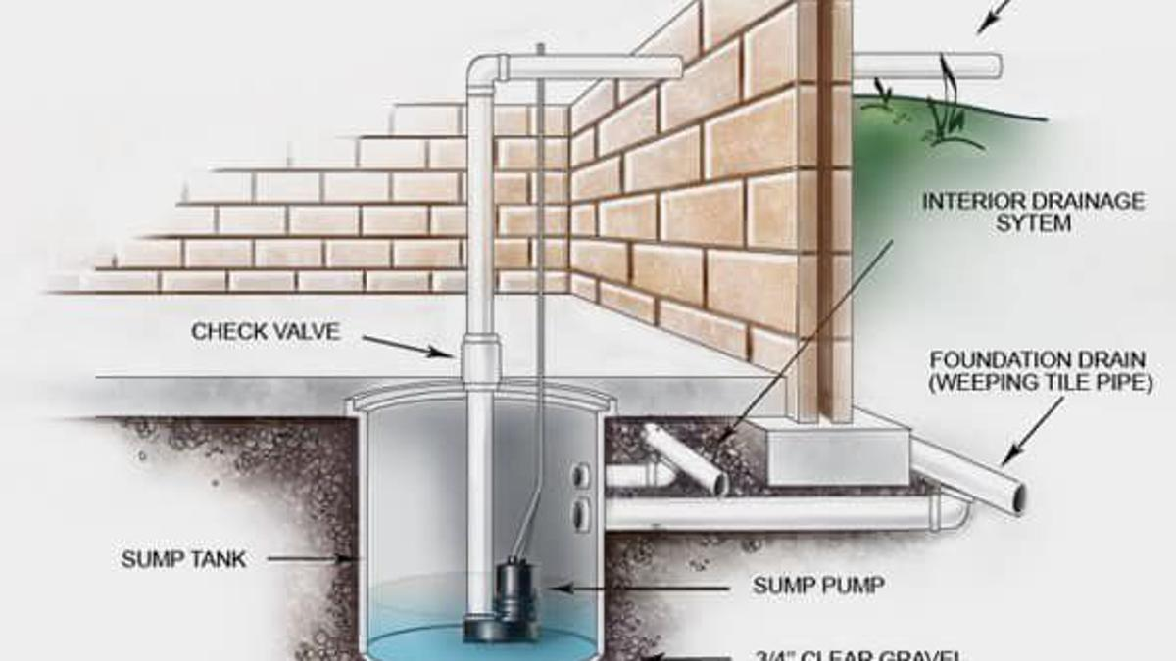
Figure 1 a sketch of a sump pump
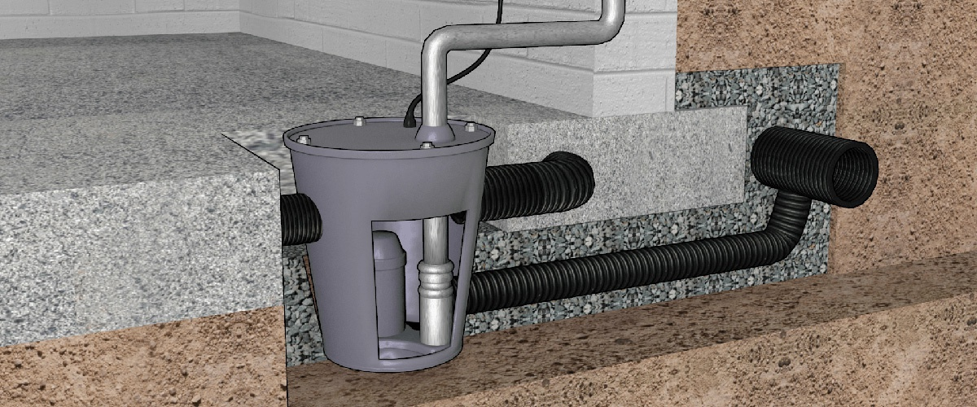
Figure 2 a sump pump cross sectional view

Figure 3 a sump pump in operation

2.0 DESCRIPTION AND FUNCTIONS OF MAJOR PARTS

2.1 Motor
Most sumps uses a very poweful electric motor to run the pumps which have a rating of a quarter to 1 hp which makes them capable of handling even the worst flooding and high water pressure without difficulty. Motors are very essential parts in the smooth running of any machine especially centrifugal pumps and milling machines which operate at very high revolutions. The power of a motor determines the possible work output of the machine.below is an image of an electrical motor used in pumps

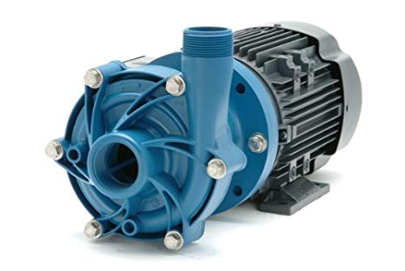
Figure 4 a sump pump motor

2.2impeller
An impeller is a rotating component of any centrifugal pump that accelerates fluid outward from the centre of rotation, thus transferring energy from the motor that drives the pump to the fluid being pumped (manuals, seloc marine 2003-2012). An impeller is a fan-like structure that is attached to the motor assembly.it has fins designed in a way that maximizes the transfer of power to the fluid from the impeller. It creates centrifugal force during its rotation that produces a pressure difference between the mouth of discharge and the intake with a higher pressure at the discharge. This makes the water funnelled into it and later to the discharge pipe.the discharge of the pump depends on the power developed by the electric motor.the following is an image of an impeller
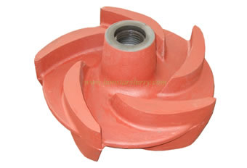 Figure 5 a sump pump impeller

2.3 discharge
It is a tube which is cylindrical shaped and open on both ends. Can be at sometimes cone shape at one edge and cylindrical shaped on the other edge. They help to funnel the water into the discharge pipe which in turn takes the water out of the pump.
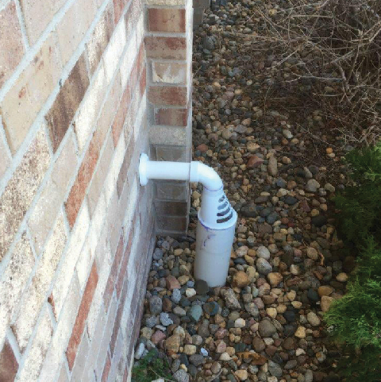
Figure 6 a discharge

2.4 discharge pipe
It may be a hose pipe, copper pipe or a PVC pipe. The most suitable type of discharge pipe is the PVC type due to its capability to withstand the corrosion and high pressure.the discharge pipe should be long lasting. Normally the discharge pipe does not affect the functioning of the pump unless in other cases where clogging can lead to exaction of pressure which then can trigger the back flowing of the discharge fluids to the pump which will in turn affect it efficiency
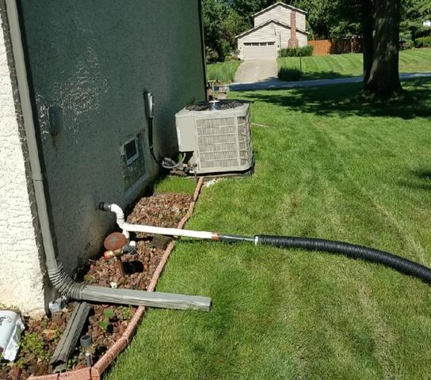
Figure 7 discharge pipes

2.5 switches
There are many types of switches but most commonly known is the float switch. Comprise of a plastic float with vacuum in it attached to the switch. The float acts as the trigger for operating the switch. When the water pressure pushes the float up, the switch turns the motor on and the sump pump begins to pump the water out (Herman, 2012). Some float switch contains 2-stage switch in the case that the liquid rises to the trigger point of the first stage the pump is activated, in cases where the water levels continue to rise may be due to clogging the 2nd stage is triggered. This stage most commonly may switch off the source of the liquid, activate an alarm or both (Liptak, 2003).The sump tank/pit has a higher and lower threshold levels.the lower level is to prevent the electric motor from overloading the running capacitors by running while pumping no water as this will destroy it. Below is an example of a float switch
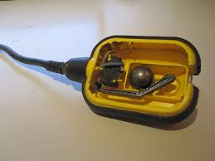
Figure 8 a float switch

2.6 check valve
Check valves are used in almost each water related machineries. For example in domestic water heating system, check valve is used to prevent vertical convection especially in use of solar energy. Rain water harvesting systems also use heck valves to prevent contamination of water with primary water supplies. It can be placed in the discharge or in the water inlet. In case the sump pump which is automated, once the water has been pushed out and the motor stops, some water remains in the pipes which can flow back into the pump causing malfunctioning of the pump. Check valve is used in blocking the return of the water into the motor. (Christopher., Dickenson, T. 1999)
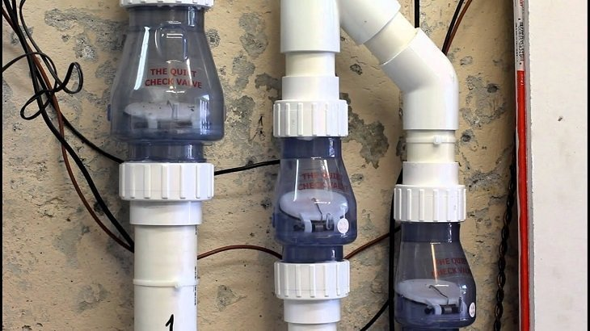
Figure 9 check valves

3.0 CONCLUSION

3.1 Functional Overview
A sump pump is a very important thing to have in a home or an industry. It helps reduce stagnation of dirty water which might in the end cause diseases to people or flooding in the buildings. It also helps prevent buildings from weathering off as water is a great agent of weathering off of buildings. It also helps reduce the ground water and proper disposal of rain water to keep surfaces dry thus prevention of bacterial infections. When surfaces are wet bacteria and fungus such as mold and mildew tends to germinate in surfaces. Sump pumps helps to keep the surfaces dry thus prevention of such growth. Sump pumps are installed with an alarm that helps alert the home owner that the water levels are too high and there is need to discharge. Water is known to be an agent of soil erosion, stagnation of water on the surfaces destabilizes the soil thus making it prone to soil erosion.too much water might reduce soil compaction that might bring down buildings

3.2 Operating cycle
A sump pit/tank found in a basement’s underground part is used to collect excess or waste water that need to be drained. As water accumulates in the sump pit the pump is turned on by a floating switch as discussed earlier. The building must have pipes through which the liquid moves from the building to far away from the foundation. At the end of the pump there is one way valve called a check valve which prevents the backflow due to the pressure head developed by pumped water. A pressure sensor or a float activator enables the sump pump to start automatically. Water exacts more force on the sensor. Air exacts less force. An air filled ball floats (vacuum) and it moves the arm as water increases. A centrifugal pump attached to an electric motor is used by a sump to move the water. When the switch is on power flows through the electric motor and the mechanical power developed powers the pump. Water is moves from the sump tank to the pump chamber and an impeller which acts when the motor is on pushes the water out through the discharge. A low pressure area is created at the inlet of the pump and the void created in the pump chamber is then filled with water from the pit and as the impeller spins water is pushed out. When the water level goes down the float switch is turned off and the electric motor goes off too. This then stops the pump until the water reaches the threshold level again

4.0 REFFERENCE
Manuals, Seloc Marine. Volvo Penta Stern Drives 2003-2012: Gasoline Engines & Drive Systems (Seloc Marine Manuals. Seloc Publishing. ISBN 978-0893300746
Stephen Herman, Understanding Motor Controls, Nelson Education, 2012, ISBN 1133713912,
Bela G. Liptak (ed.), Instrument Engineers' Handbook, Fourth Edition, Volume One: Process Measurement and Analysis, CRC Press, 2003, ISBN 1420064029
Christopher. Dickenson, T. (1999). Valves, piping, and pipelines handbook (3rd Ed.). Oxford, UK: Elsevier Advanced Technology. ISBN 9781856172523. OCLC 41137607

